RSign for Salesforce User Guide

Contents

RSign for Salesforce User Guide 1

Pre-requisites 1

Integration usage 1

Use Cases: 2

Use Case 1: Sending an RSign® Envelope 2

Use Case 2: Sending an RSign OneClick™ Template 5

Templates Tab 7

Select Templates 7

Manage Templates 11

OneClick™ Templates 11

RSign Status Tab 15

Activity History 17

# RSign for Salesforce User Guide

The RSign® integration for Salesforce allows users to send documents for eSignature directly from their Salesforce platform using the RSign® system. It enables users to send envelopes to different Salesforce objects, monitor the status of sent envelopes, automatically receive signed documents in the corresponding Salesforce record, and create, share and modify templates, all within the Salesforce interface. Additionally, this integration allows to automatically prefill data from Salesforce fields into templates en route to the recipients and backfill data filled by the recipient back into Salesforce.

## Pre-requisites

Salesforce users must have:

* active RSign® login credentials
* an appropriate RSign® user plan.

## Integration usage

Please click on the following article to read how to set up the RSign® service for Salesforce.

## Use Cases:

Different RSign® use cases are available to Salesforce users within this integration, as described in each use case below.

• Use Case 1: Sending an RSign Envelope

• Use Case 2: Sending an RSign OneClick™ Template

### Use Case 1: Sending an RSign® Envelope

1. Login to your Salesforce account and select the record to which you need to send a document for signature. Once in the profile, click on the funnel icon  and select *“Send with RSign”* from the options.

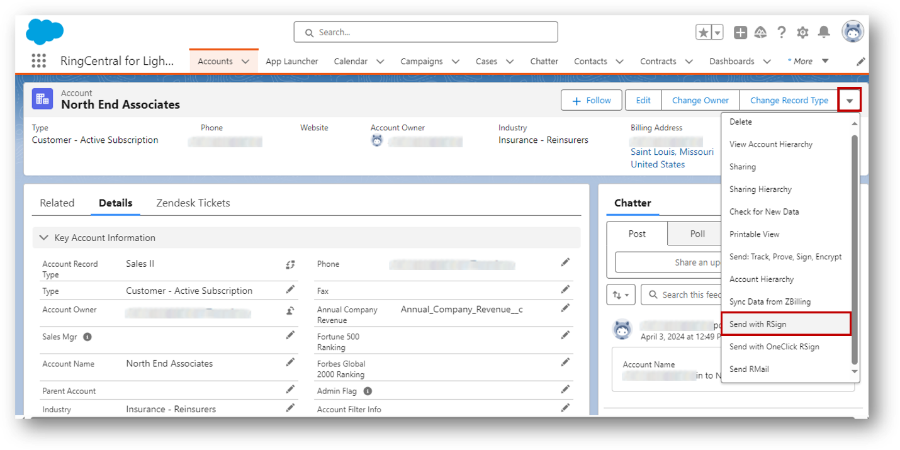

1. RSign for Salesforce has the option to send documents as a one off- or leverage previously created templates for commonly used documents to save time. If you wish to use an existing template, skip to step 4. To prepare your envelope to send as a one-off start by attaching the desired document(s) from the “add document” dropdown and set up the settings on the left panel to change any default settings.

1. Next add your recipient(s) by clicking on the “Add Recipients” button. You can select recipients from Salesforce objects such as contacts, leads, users or add a new one. You can also choose the signing order by selecting the “Sign in Sequence” checkbox. *

*The order in which signers will receive the signature request will depend on how it was set up while creating the RSign Template.

1. If sending the envelope as a one off, compose the message in this section or select a Salesforce Email Template. If sending an existing RSign template, select *“RSign Template”* and choose the desired template from the dropdown. Note that RSign templates will prepopulate all the sections and control fields corresponding to that previously created template. When ready, click on the *“Next”* button on the top right corner to prepare the document.

1. If sending as a one-off, drag-and-drop the desired control fields into the document. If using a template, the control fields will be automatically added but you may add/edit control fields at this stage if needed. When finished, click the *“Send”* button for recipient signoff.

### Use Case 2: Sending an RSign OneClick™ Template

The most efficient way to use RSign for Salesforce is with OneClick™ templates. With OneClick™ templates all you have to do is add your recipient information and RSign will take care of the rest.

1. In the desired Salesforce record, click on the funnel icon  and select *“Send with OneClick RSign”* from the options.

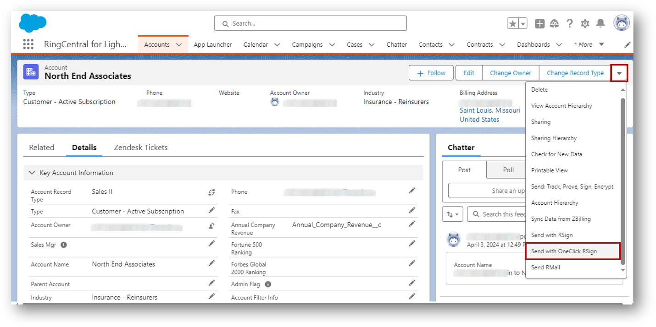

1. In the pop up, select the desired OneClick™ template, (previously created from the *“Template”* section) and click on the *“Next”* button.

1. Verify recipients or select recipients from Salesforce objects such as contacts, leads, users or add an additional or new recipient by manually entering the name and valid email address. Once ready, click on the *“Send”* button and the message template is pre-filled according to mappings, sent, and after signoff, backfilled into the Salesforce record, automatically. **

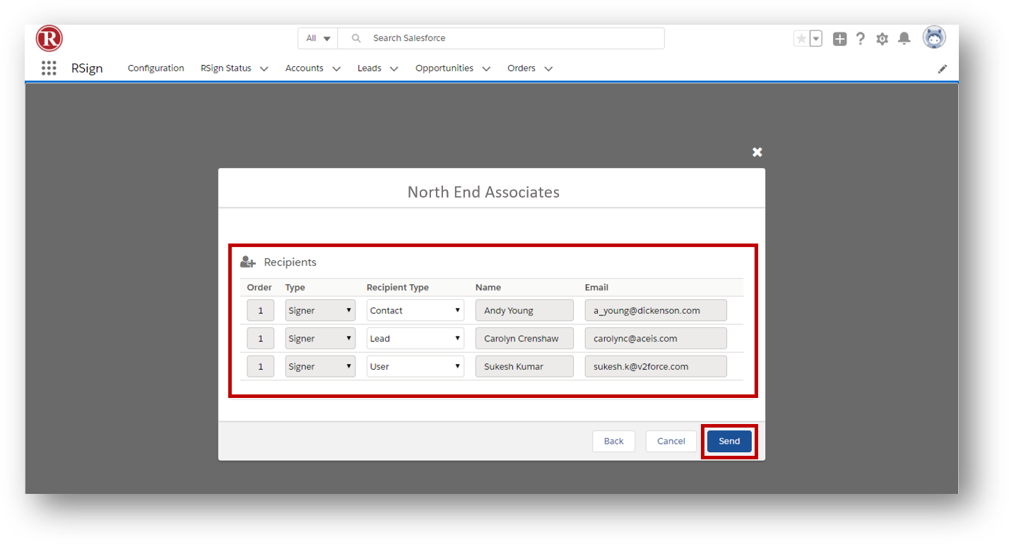

**If any RSign field is not mapped to a Salesforce field, then that field will be highlighted in red indicating that there is no mapping for a particular control. This can then be mapped ad-hoc.

## Templates Tab

Within the templates tab you’ll find three sections of templates: selecting templates from the RSign account to be available in Salesforce, managing those templates, and creating OneClick™ templates with mapped pre-flll and/or back-fill data.

### Select Templates

1. The list of all templates will be displayed here with all the details such as template name, template owner, created date & last modified date, to which object that template is mapped to. This information is fetched from the RSign system. It will display templates created in Salesforce.com app or templates created in the [RSign web app](https://app.rsign.com).

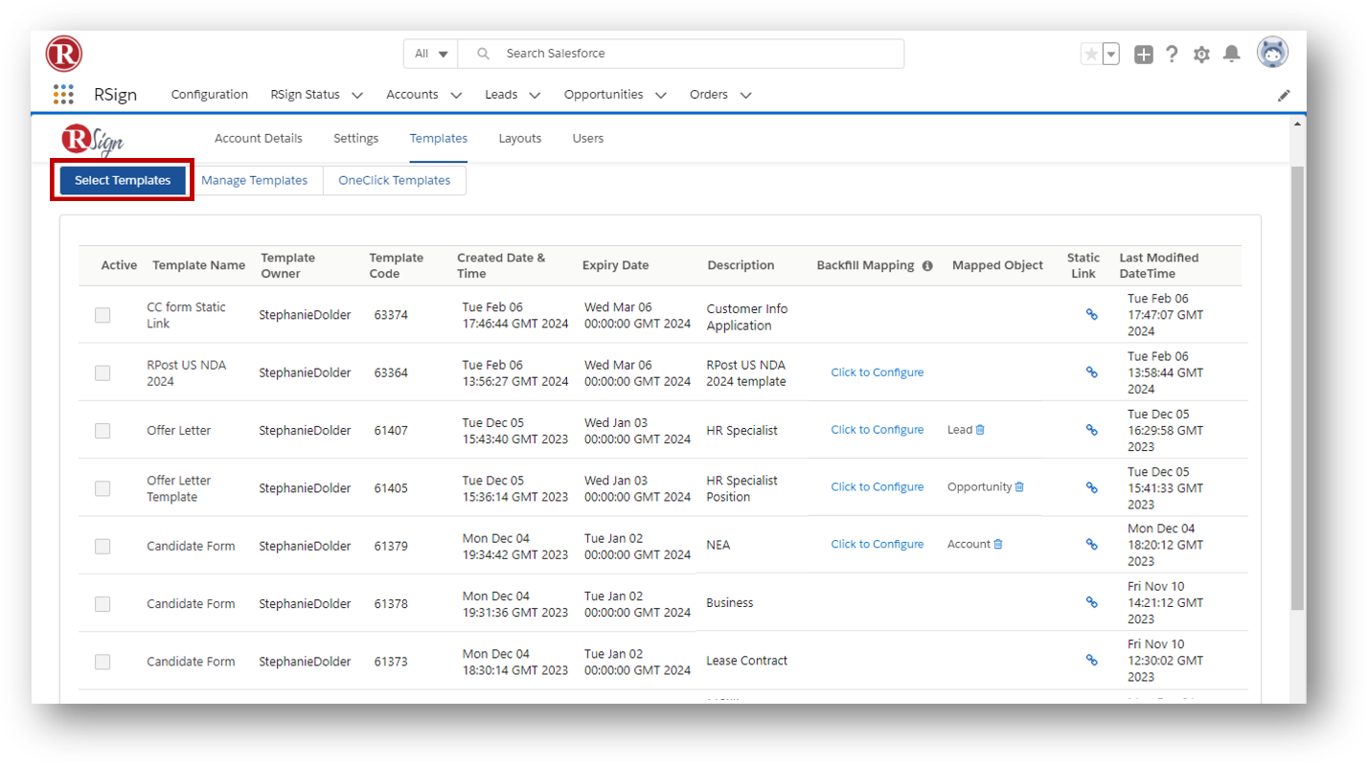

1. Only the selected active templates will be available while sending from any Salesforce object detail. Activate the desired templates by clicking on the checkbox.

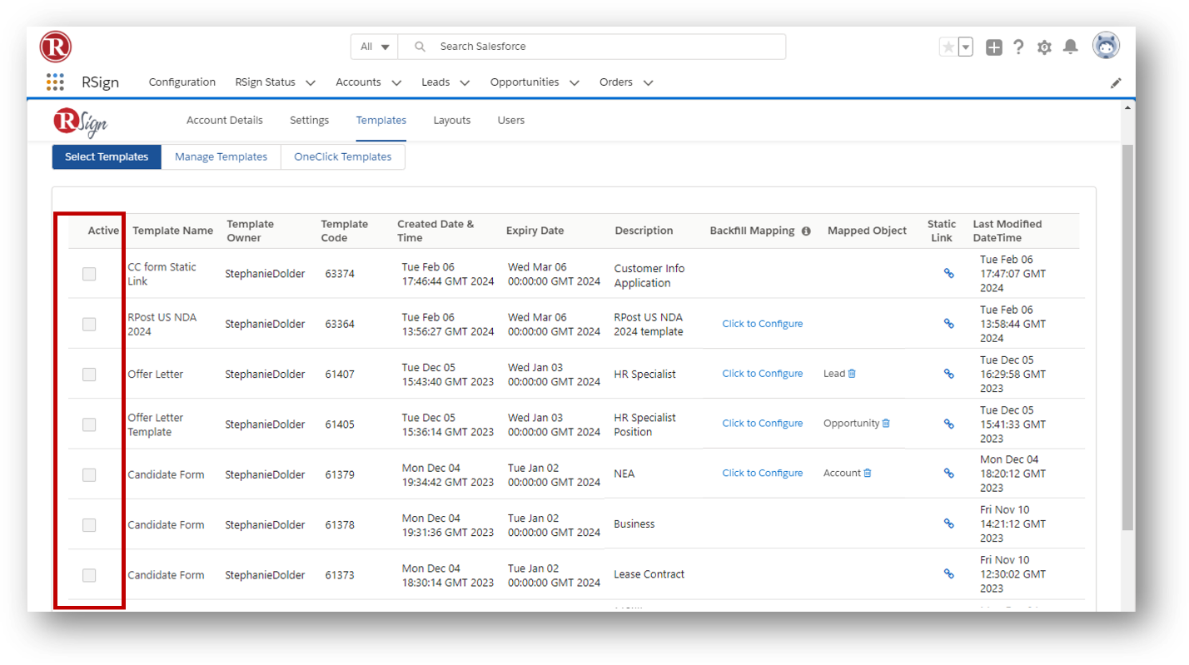

1. The *Static Link* column will display a link (if enabled when creating the template). This allows you to copy the link and paste it in a Salesforce Email template to send for e-sign. TIP: you can send email templates encrypted with the **RMail for Salesforce app**, and those templates can contain a static RSign link (ask your account manager for more details).

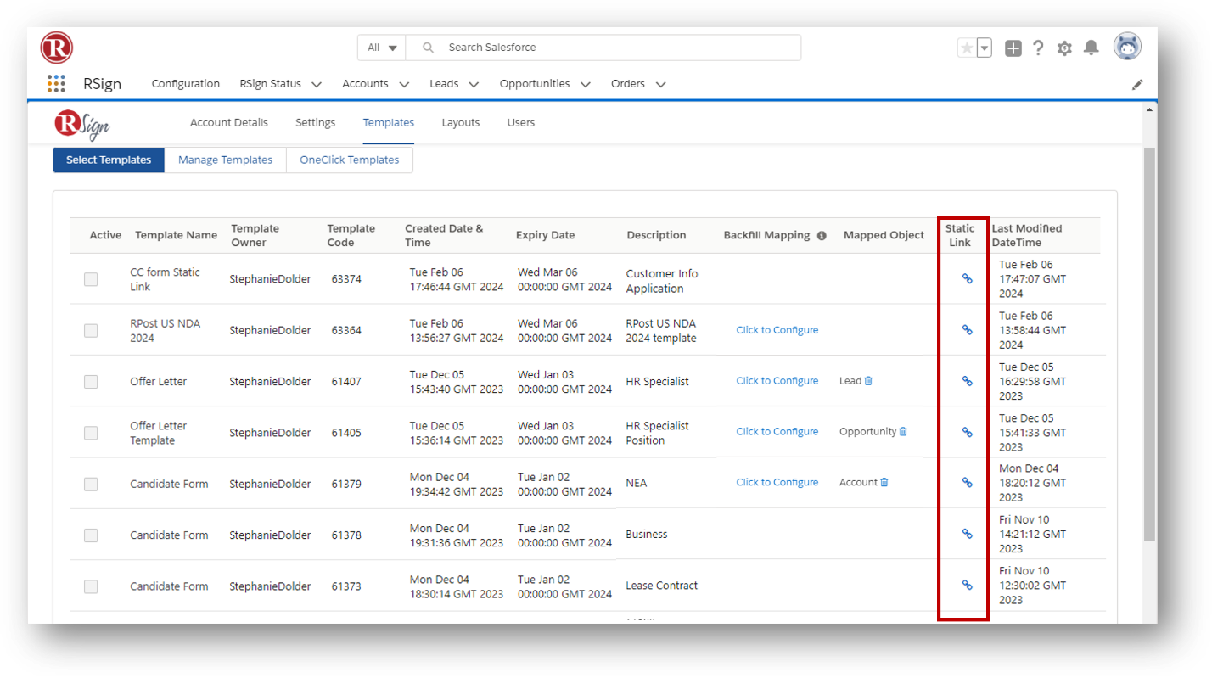

4. The *Backfill Mapping* column is used to configure the mapping of RSign to Salesforce objects with their fields. Backfill configurations can be deleted by using the *“Delete”* icon beside mapped object name.

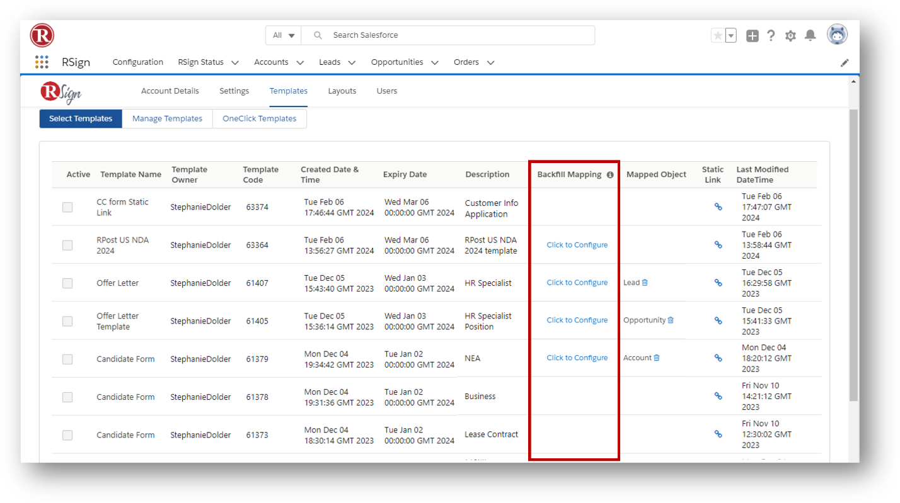

#### View or Edit Backfill Mapping for Templates

Set data from recipient filled forms and documents to pre-fill or backfill from or into mapped Salesforce fields to then trigger follow-on Salesforce activities. This is a powerful feature. View or edit current mappings for a template by clicking the Backfill Mapping “Click to Configure” link.

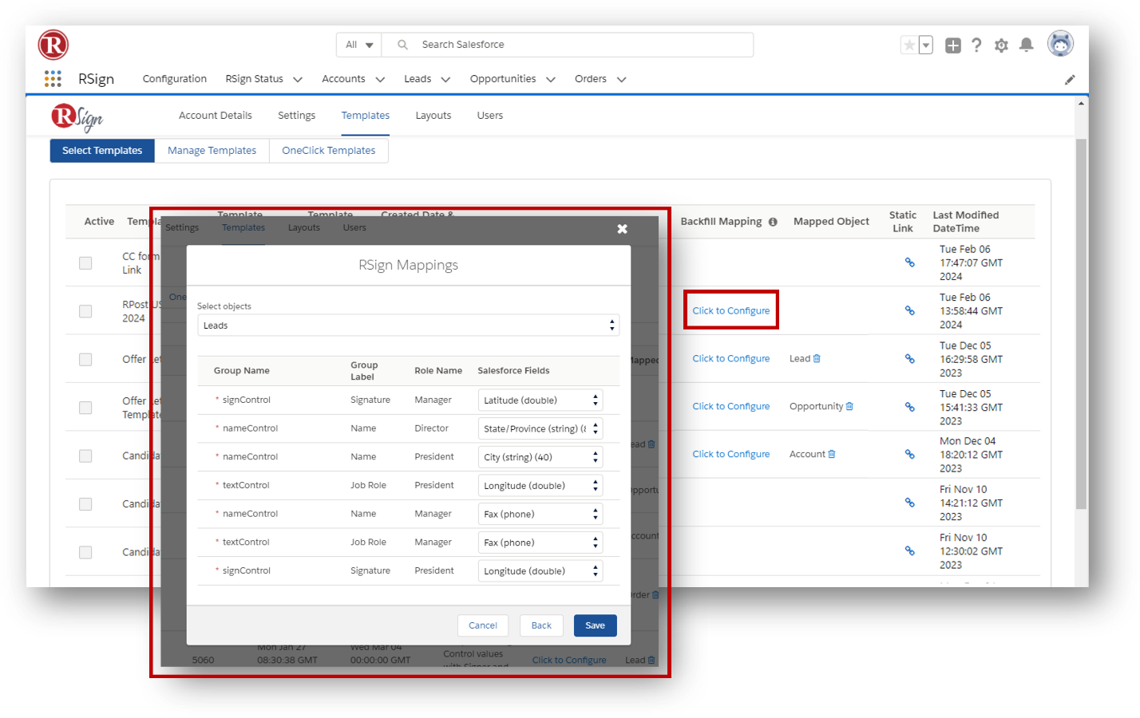

### Manage Templates

From the Manage templates tab view, create, edit & delete templates from within the Salesforce interface. A parallel view is available within the [RSign web app](https://app.rsign.com). Learn how to create an RSign template [here](https://support.rpost.com/hc/en-us/articles/360033798673-How-to-Create-a-Template).

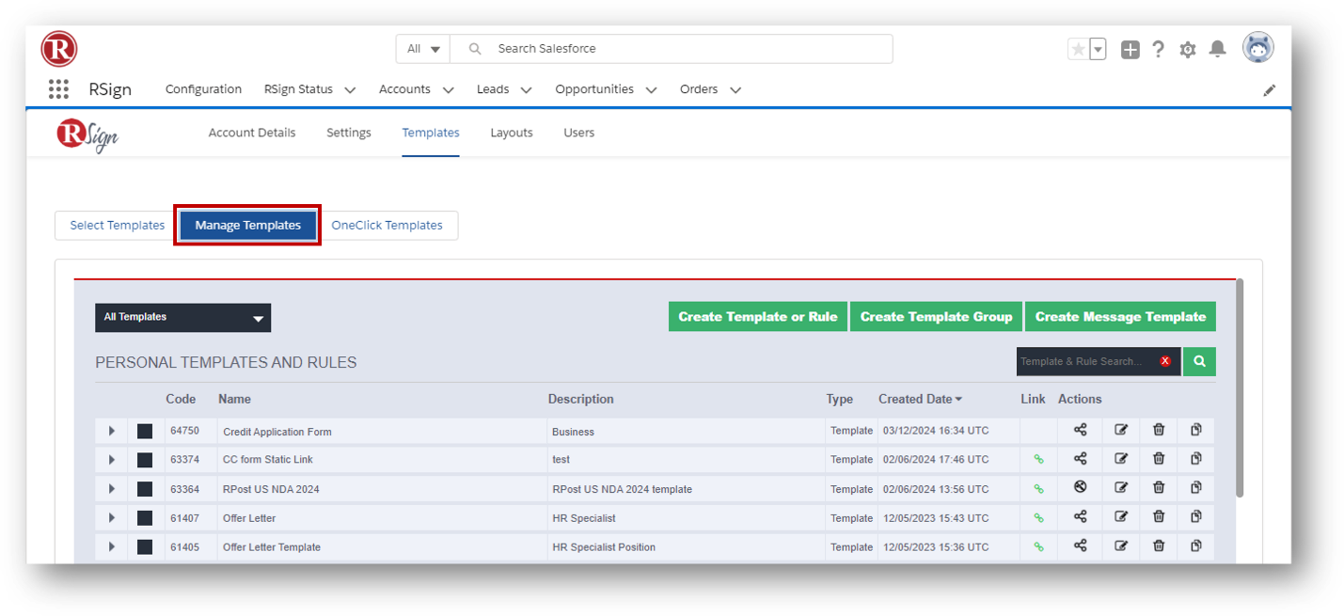

### OneClick™ Templates

Creating OneClick™ Templates allows you to set up a template, map pre-filling of data from Salesforce fields into the template en route to the recipients, and map backfilling data that the signers fill in when signing, back into Salesforce fields. Reminder emails and other parameters can be set in the settings related to the template.

1. To create a OneClick™ template, select the *“OneClick Templates”* tab and click on the “*Create New”* button.

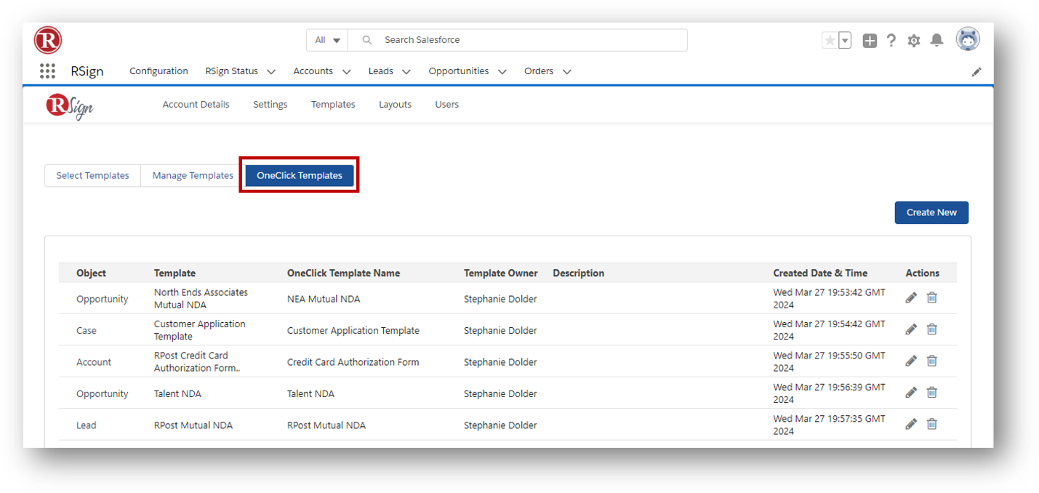

1. In the “*Template Details”* section, find the appropriate previously created template from the dropdown menu.

1. In the “*Pre-fill Mapping”* section*,* use the pull downs to map any ***pre-fill fields*** (data from Salesforce to prefill the form before sending for fill and e-sign). Add any designated **recipient roles** and select the **order of signing**.

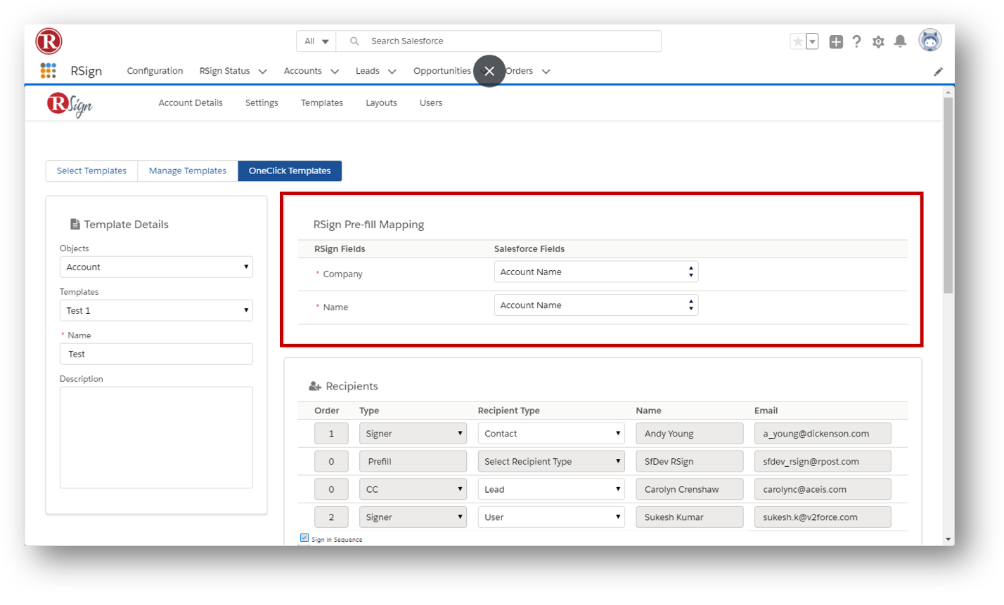

1. In the “*Recipients”* section*,* add any designated **recipient roles** and select the **order of signing**.

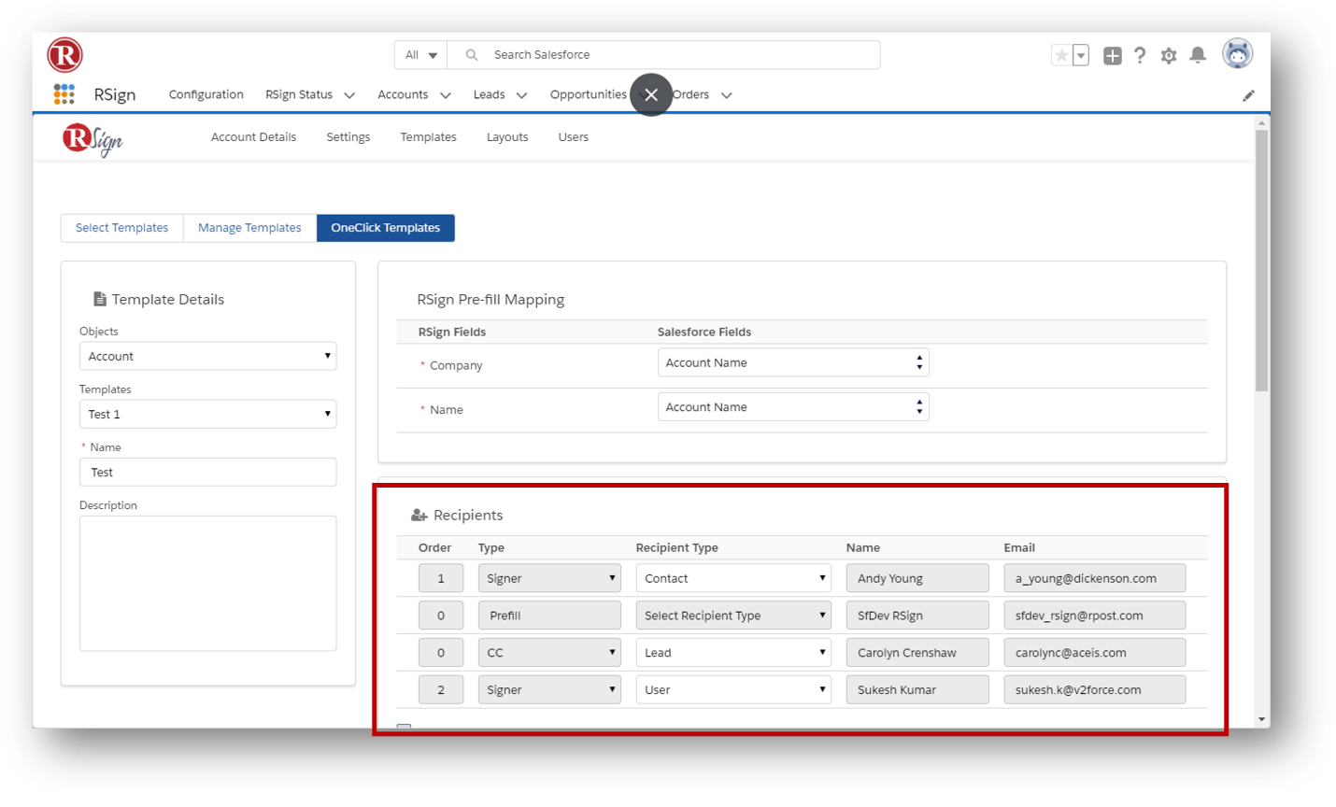

1. In the *“Add Message”* section, choose to use the *“RSign Template”* option to use a message associated to a template or a “*Salesforce template”*. You can modify the message template for this OneClick template here and save, or modify the message before sending the document for signature.

## RSign Status Tab

Review RSign data that has been backfilled into specific mapped fields (see Backfill Mapping section) or view this in the RSign Status tab.

The RSign Status tab has columns that may be configured by the Salesforce administrator to prioritize the information that is important to you in the view. Below is an example before any customization.

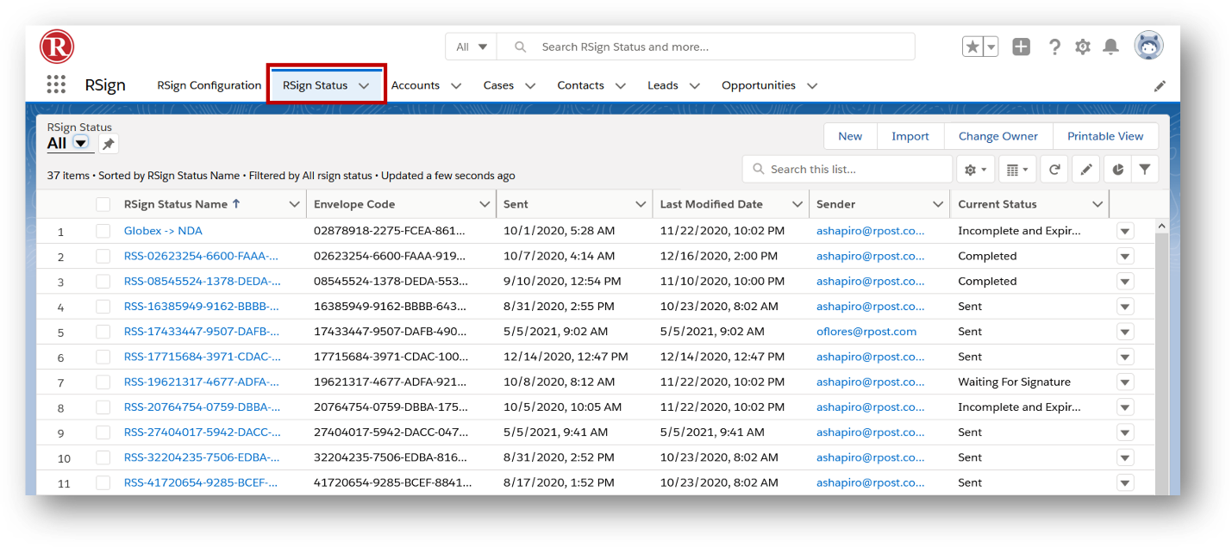

The RSign status tab will have an RSign Status record generated after sending an RSign email. By clicking on an RSign Status Name record, you can view the details of that record, and set follow up activities from that record.

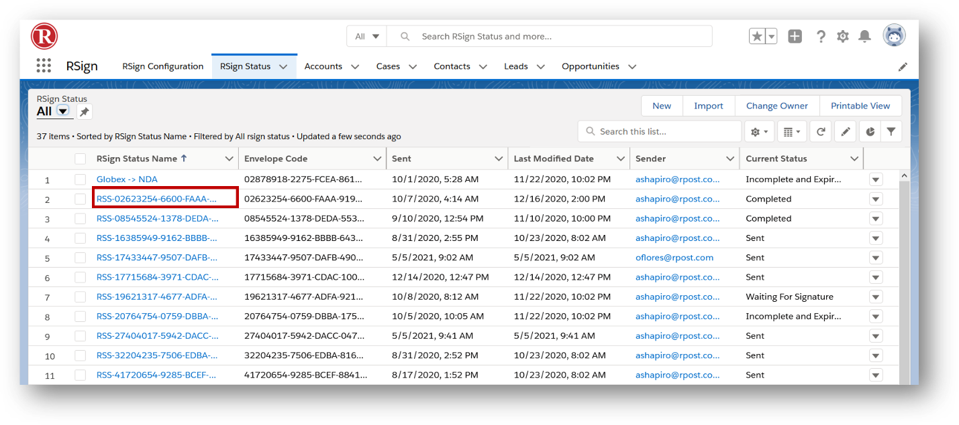

The RSign status contains details like envelope code, sender’s address, subject, delivery status, from which salesforce object the email has been sent, and more. The completed document is prepared as an authentication record in the form of a digitally signed PDF and is accessible. More information on E-Sign Authentication is in the RSign support center.

Click on the “Backfill Mapping” button to be redirected to the page that shows the mappings of the Objects where the information from the RSign Status is populated into the corresponding Salesforce field.

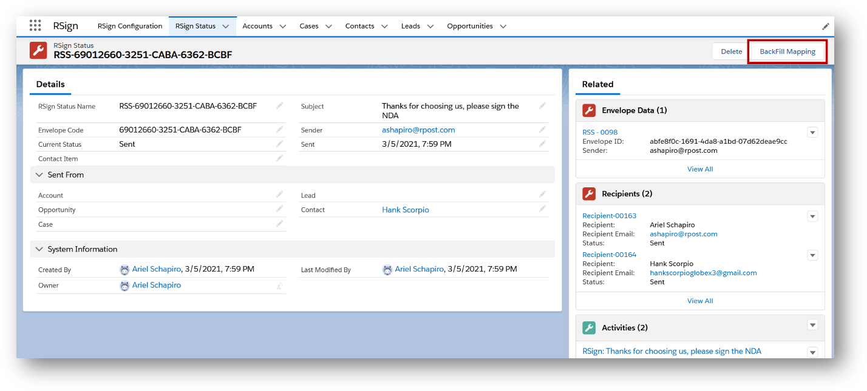

## Activity History

An “Activity History” record will also be created related to the recipients and the object the message was sent from. It will include the message subject, content and recipients.

